**LAB 10**

**OBJECTIVE**

To be familiar with PHP

**DESCRIPTION**

The term PHP is an acronym for PHP: Hypertext Preprocessor. PHP is a server-side scripting language designed specifically for web development.

PHP can actually do anything related to server-side scripting or more popularly known as the backend of a website. For example, PHP can receive data from forms, generate dynamic page content, can work with databases, create sessions, send and receive cookies, send emails etc. There are also many hash functions available in PHP to encrypt user’s data that makes PHP secure and reliable to be used as a server-side scripting language. So these are some of the abilities of PHP that makes it suitable to be used as server-side scripting language.

PHP can run on all major operating systems like Windows, Linux, Unix, Mac OS X etc. Almost all of the major servers available today like Apache supports PHP. PHP allows using a wide range of databases. And the most important factor is that it is free to use and download and anyone can download PHP from its official source : www.php.net.

**CODE**

<?php

// echo 'All setup!';

// $numbers = ['Zero','One','Two','Three','Four','Five','Six',

'Seven','Eight',"Nine",'Ten'];

echo '<ul>';

for($i=1; $i<=10;$i++)

{

// echo "<li>$numbers[$i]</li>";

echo '<li> 9 * '.$i.' = '.(9 * $i).'</li>';

}

echo '</ul>';

?>

**OUTPUT**

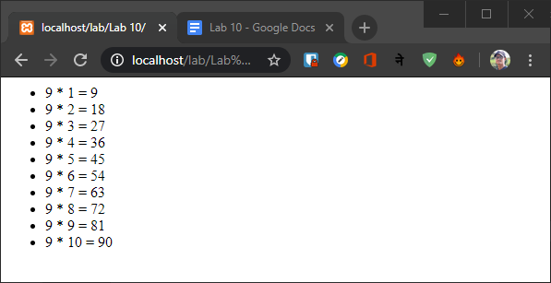

**CODE**

<?php

$numbers = ['','Rock','Scissor','Paper'];

if (isset($_GET['uchoice']))

{

$uchoice = $_GET['uchoice'];

$cchoice=rand(1,3);

echo 'You chose '.$numbers[$uchoice];

echo' & Computer chose '.$numbers[$cchoice].'. ';

if($uchoice == 1 && $cchoice == 2)

echo 'You Won.';

else if($uchoice == 1 && $cchoice == 3)

echo 'Computer Won.';

else if($uchoice == 2 && $cchoice == 1)

echo 'Computer Won.';

else if($uchoice == 2 && $cchoice == 3)

echo 'You Won.';

else if($uchoice == 3 && $cchoice == 1)

echo 'You Won.';

else if($uchoice == 3 && $cchoice == 2)

echo 'Computer Won.';

else

echo 'Its a tie. Please play again.';

}

?>

<!DOCTYPE html>

<html>

<head>

<title>RSP</title>

</head>

<body>

<br>

<a href="rsp.php?uchoice=1">Rock</a><br>

<a href="rsp.php?uchoice=2">Scissor</a><br>

<a href="rsp.php?uchoice=3">Paper</a><br>

<a href="rsp.php">Play Again</a>

</body>

</html>

**OUTPUT**

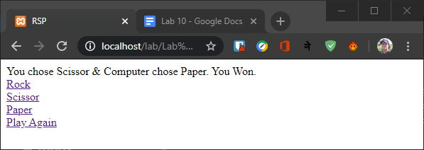

**CODE**

<?php

$records = [];

$records[] = ['name'=>'Ramesh','extension'=>124];

$records[] = ['name'=>'Anjali','extension'=>742];

$records[] = ['name'=>'Kriti','extension'=>824];

$records[] = ['name'=>'Sampad','extension'=>112];

// echo'<pre>';

// print_r($records);

?>

<table border="1">

<tr>

<td>Name</td>

<td>Extension</td>

</tr>

<?php

foreach($records as $row)

{

echo '<tr>';

echo '<td>'.$row['name'].'</td>';

echo '<td>'.$row['extension'].'</td>';

echo '</tr>';

}

?>

</table>

**OUTPUT**

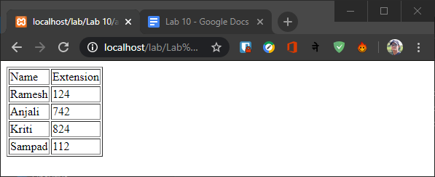

**SUMMARY**

In this lab, we got familiar with PHP (Hypertext Preprocessor), its syntax and wrote some programs in PHP programming language. Its syntax was difficult to deal with at first time.

**COMMENT**